**IOT – Hands-On 3**

**מגישים:**

מאיה סגל – 211767637

אוראל חרזי- 209494368

**Test 1:**

* **Configuration:**
  + clean_session=True
  + QoS=0
  + Broker: broker.hivemq.com
  + Topic: IOT/class/house/sensor/1/555
* **Expected Behavior:**
  + With clean_session=True and QoS=0, the subscriber should receive the message only if it is connected before the message is published. If the subscriber connects after the message is sent, the message will not be received.
* **Actual Behavior:**
  + In this test, the subscriber was connected before the message was published, and it successfully received the message "Test message for Test 1".
  + Both the publisher and subscriber connected to the broker and disconnected cleanly.
* **Publisher Screenshot:**  
  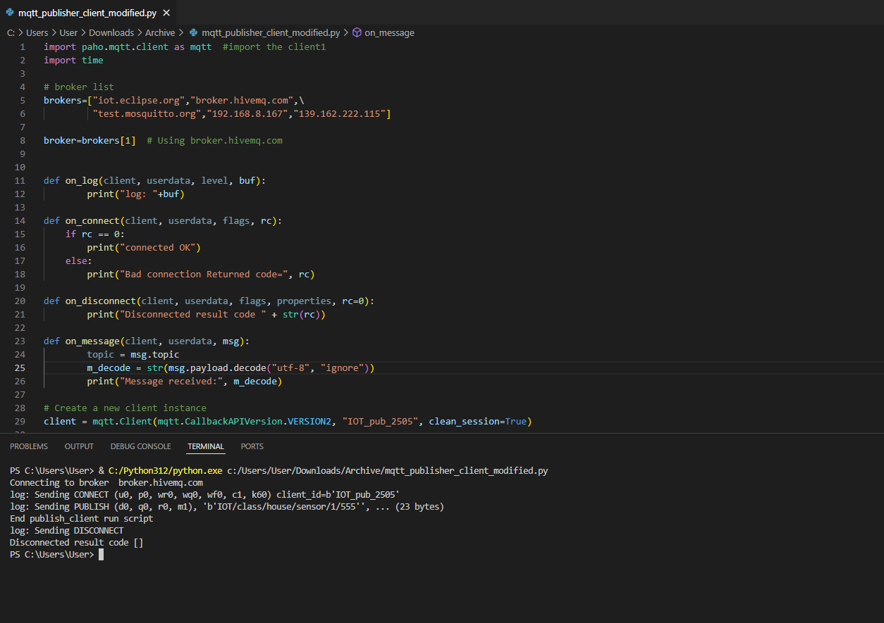
* **Subscriber Screenshot:**  
  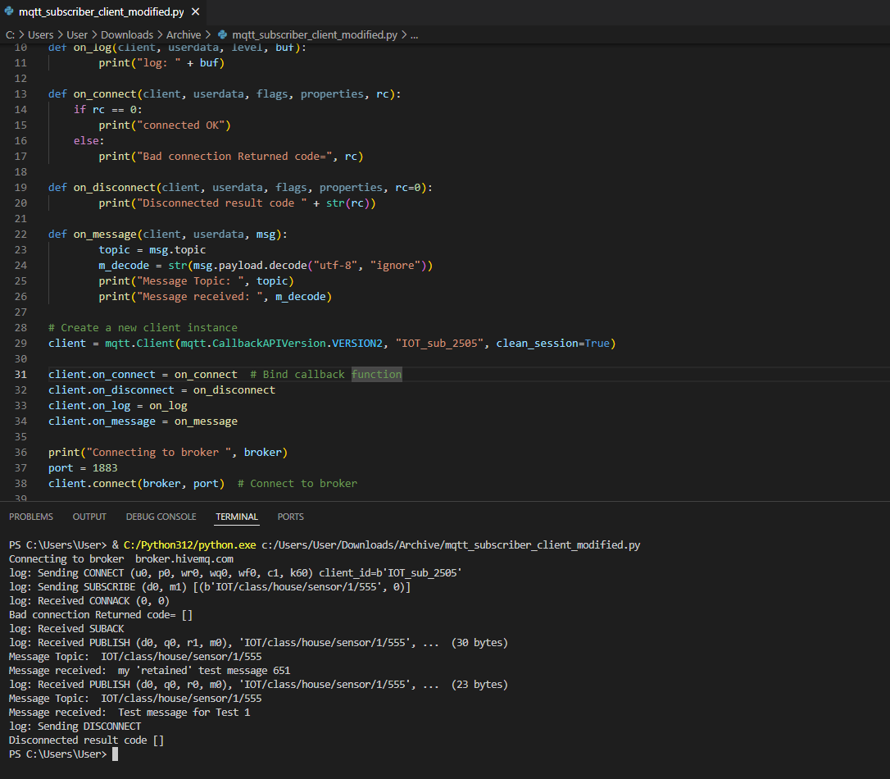
* **Result:**
  + The test was successful, and the actual behavior matched the expected outcome.
  + If the subscriber were disconnected and reconnected after the message was published, no message would have been received, as expected.

### **Test 2:**

#### ****Configuration****:

* clean_session=False
* QoS=0
* **Broker**: broker.hivemq.com on port 1883
* **Topic**: IOT/class/house/sensor/1/555

#### ****Expected Behavior****:

* When clean_session=False, the broker should remember the subscription for the subscriber, even after disconnection.
* However, since the message is published with QoS=0, the broker will not store the message if the subscriber is disconnected at the time of publishing. Therefore, the message should only be received if the subscriber is connected while the publisher sends it.

#### ****Actual Behavior****:

* In this test, the subscriber was connected when the message "Test message for Test 2" was published, and it successfully received the message.
* The subscriber also received a previously retained message: "my 'retained' test message 651".
* Both the publisher and subscriber connected to the broker and disconnected cleanly.

#### ****Publisher Screenshot****:

#### 

#### ****Subscriber Screenshot****:

#### 

#### ****Result****:

* The test was successful, and the actual behavior matched the expected outcome. The subscriber correctly received the message while being connected, and the subscription was retained as expected.

### **Test 3:**

#### ****Configuration****:

* clean_session=True
* QoS=1
* **Broker**: broker.hivemq.com on port 1883
* **Topic**: IOT/class/house/sensor/1/555

#### ****Expected Behavior****:

* With clean_session=True, the broker does not retain the subscriber’s session when it disconnects. Therefore, when the subscriber reconnects, it will not receive any messages that were published while it was disconnected.
* Since QoS=1 guarantees that the message will be delivered at least once, it will be delivered to the subscriber if it is connected at the time of publishing.

#### ****Actual Behavior****:

* The subscriber was disconnected after 5 seconds, and the message "Test message for Test 3" was published with QoS=1.
* After the subscriber reconnected, it did not receive the message, which is the expected behavior because clean_session=True means the subscription was not retained.

#### ****Publisher Screenshot****:

#### 

#### ****Subscriber Screenshot****:

#### 

#### ****Result****:

* The test was successful, and the actual behavior matched the expected outcome. The subscriber did not receive the message after reconnecting, as the session was not retained with clean_session=True.

### **Test 4:**

#### ****Configuration****:

* clean_session=False
* QoS=1
* **Broker**: broker.hivemq.com on port 1883
* **Topic**: IOT/class/house/sensor/1/555

#### ****Expected Behavior****:

* With clean_session=False, the broker retains the subscriber’s session even after it disconnects. This means that the subscription persists, and the broker will store the message until the subscriber reconnects.
* Since the message is published with QoS=1, the broker will deliver the message at least once when the subscriber reconnects.

#### ****Actual Behavior****:

* The subscriber disconnected after 5 seconds, and the message "Test message for Test 4" was published with QoS=1.
* After the subscriber reconnected, it successfully received the message, as expected, since the broker retained the session and stored the message.

#### ****Publisher Screenshot****:

#### 

#### ****Subscriber Screenshot****:

#### 

#### ****Result****:

* The test was successful, and the actual behavior matched the expected outcome. The subscriber correctly received the message after reconnecting, as the session was retained with clean_session=False.

### **Test 5:**

#### ****Configuration****:

* clean_session=False
* **Publisher**: QoS=0
* **Subscriber**: QoS=1
* **Broker**: broker.hivemq.com on port 1883
* **Topic**: IOT/class/house/sensor/1/555

#### ****Expected Behavior****:

* With clean_session=False, the broker retains the subscriber’s session and subscription even after disconnection.
* Since the publisher is sending the message with QoS=0, the message is delivered at most once and will not be stored by the broker if the subscriber is disconnected when it is published.

#### ****Actual Behavior****:

* The subscriber received a retained message from **Test 4** due to the session retention from clean_session=False. This is expected, as the broker stored the previous QoS=1 message from Test 4.
* For **Test 5**, the message "Test message for Test 5" was published with QoS=0, and the subscriber did not receive this message after reconnecting, as expected, since the broker does not store QoS=0 messages.

#### ****Publisher Screenshot****:

#### 

#### ****Subscriber Screenshot****:

#### 

#### ****Result****:

* The test was successful. The subscriber correctly did not receive the **Test 5** message after reconnecting, which is the expected behavior with QoS=0.